1. Installed terraform and using terraform launched required worker machines.

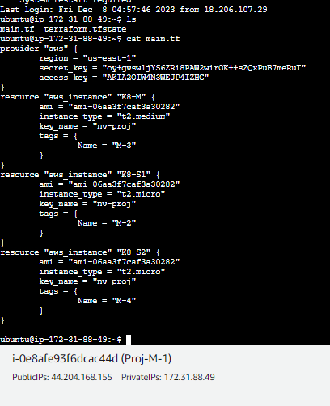

2. below are the worker node script files.

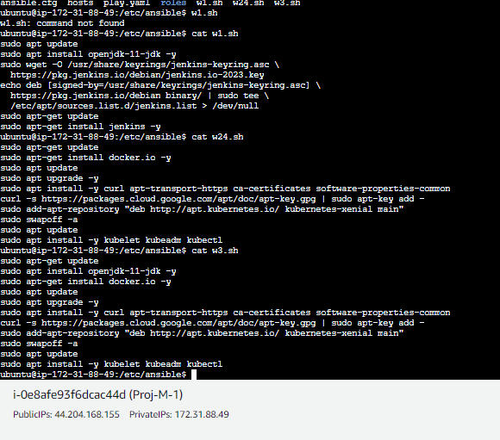

3. Using ansible installed required tools in the worker nodes.

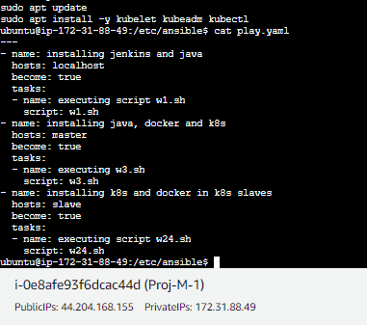

4. service.yaml file.

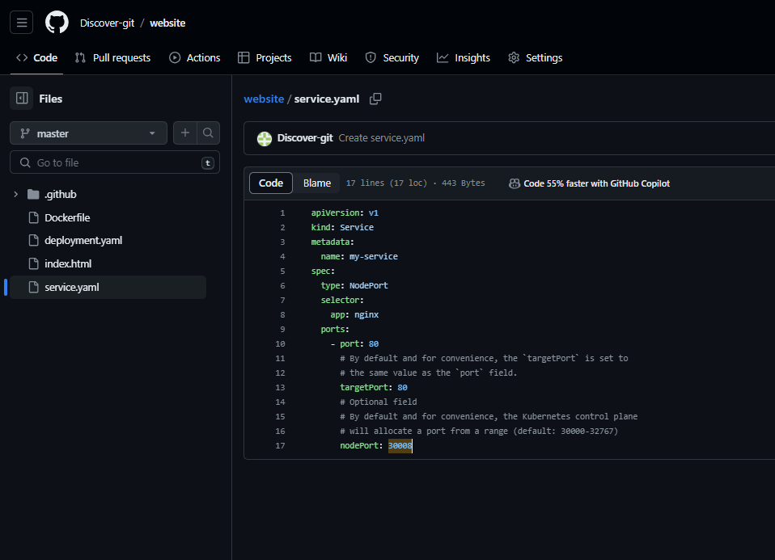

5. deployment.yaml file.

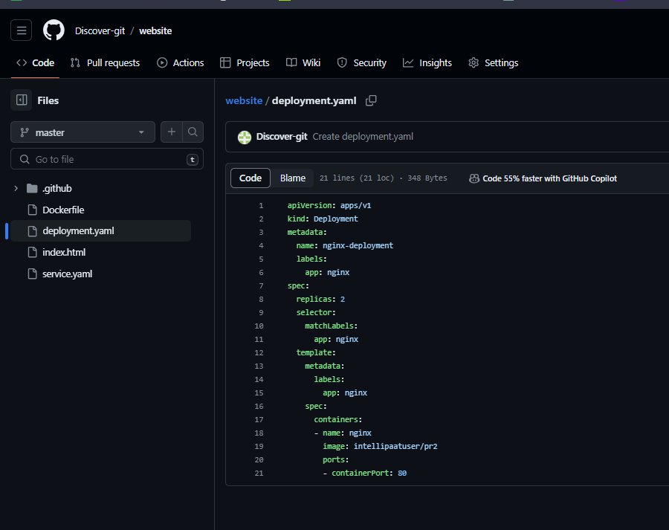

6. Jenkins configuration below.

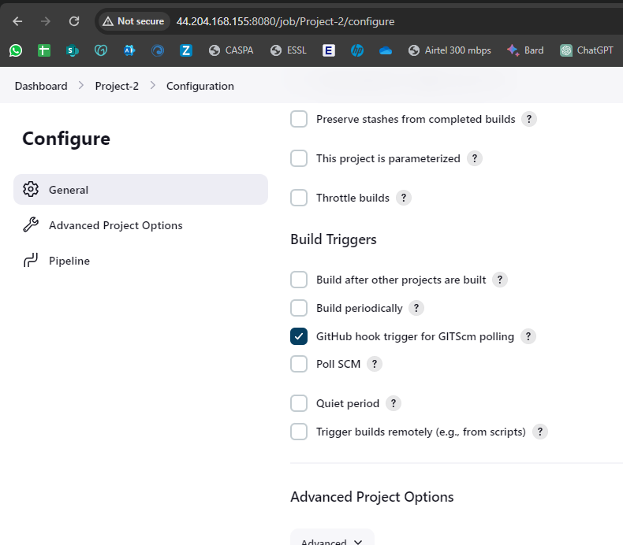

Pipeline Script file.

**pipeline {**

**agent none**

**environment {**

**DOCKERHUB_CREDENTIALS = credentials("fa79088e-80bf-4268-8649-c0107c2d2179")**

**}**

**stages {**

**stage('Git') {**

**agent {**

**label 'KM'**

**}**

**steps {**

**script {**

**git 'https://github.com/Discover-git/website.git'**

**}**

**}**

**}**

**stage('Docker') {**

**agent {**

**label 'KM'**

**}**

**steps {**

**sh 'sudo docker build . -t intellipaatuser/pr2'**

**sh 'sudo docker login -u ${DOCKERHUB_CREDENTIALS_USR} -p ${DOCKERHUB_CREDENTIALS_PSW}'**

**sh 'sudo docker push intellipaatuser/pr2'**

**}**

**}**

**stage('K8s') {**

**agent {**

**label 'KM'**

**}**

**steps {**

**sh 'kubectl delete deploy nginx-deployment'**

**sh 'kubectl apply -f deployment.yaml'**

**sh 'kubectl delete svc my-service'**

**sh 'kubectl apply -f service.yaml'**

**}**

**}**

**}**

**}**

7. job was successfully executed. Enabled GitHub webhook as well.

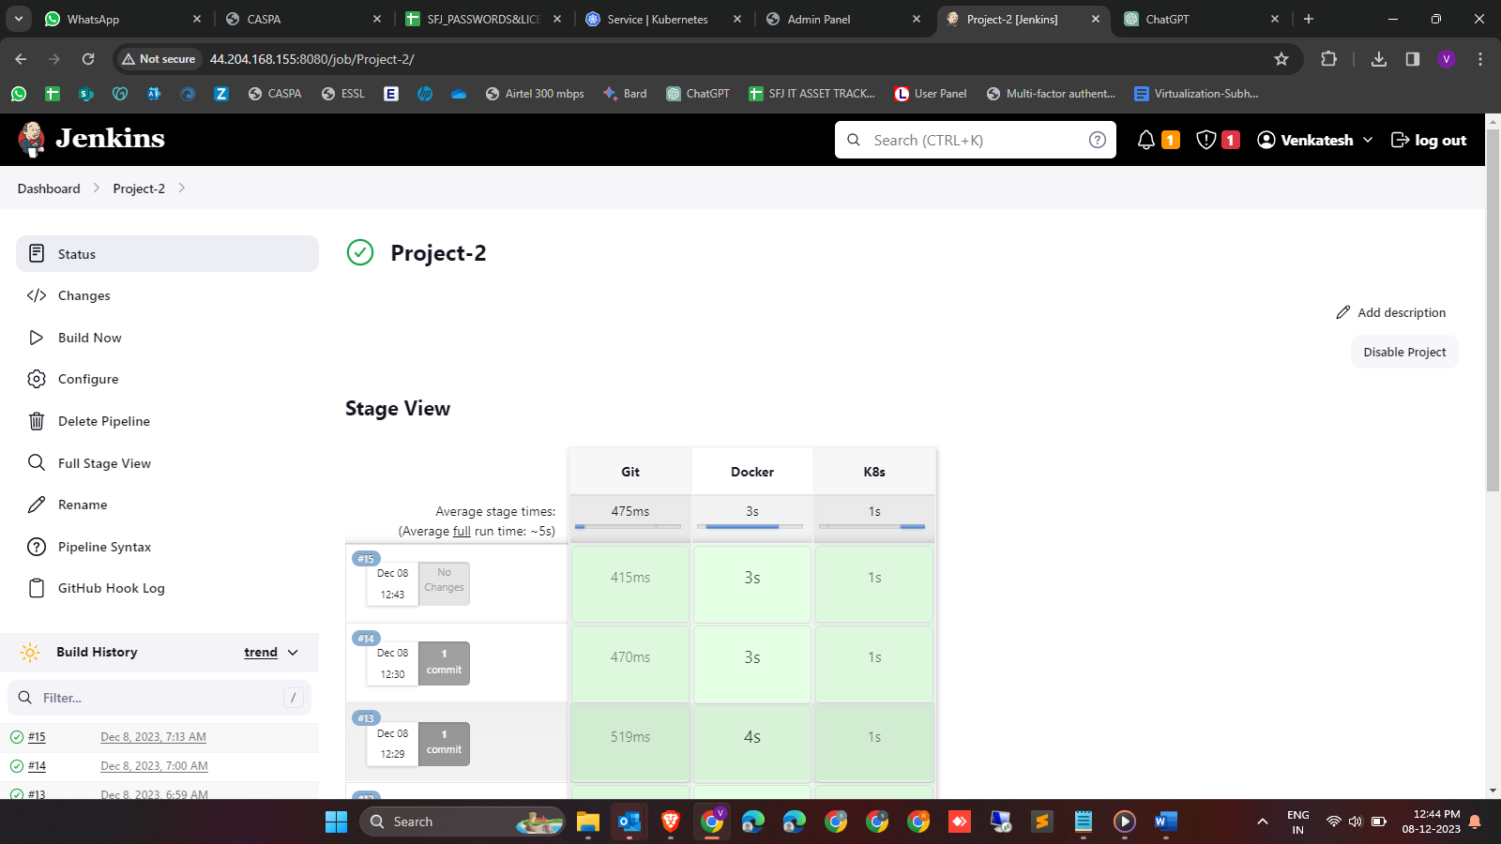

6. Kubernetes master machine.

